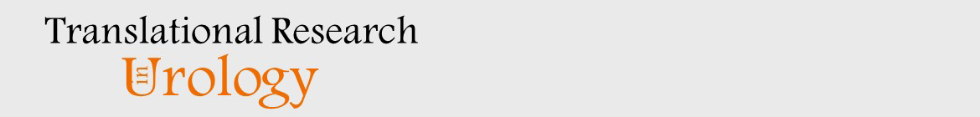
CHANGE OF AUTHORSHIP FORM
Only Before Proof Approval

Manuscript Title: Iatrogenic Glans Penis Injury During Circumcision: Clinical Spectrum, Mechanisms, and Medicolegal Implications—A Systematic Review
Running Head: Iatrogenic Glans Injury During Circumcision

Corresponding Author: Abdul Hakim Nitiprodjo

Please check all that apply.
NOT REQUIRED FOR INITIAL SUBMISSION: no authorship change has been reported. Keep this form only if the author list or order changes before proof approval.

New author(s) have been added.
There is a change in the order of authorship.
An author wishes to remove his/her name. An author’s name may only be removed at his/her own request in writing.

ORIGINAL AUTHORSHIP

List ALL AUTHORS in the same order as the original (first) submission.

Print Name
Abdul Hakim Nitiprodjo
Andi Muhammad Maulana
Prima Maharani Putri
Titik Kusumawinakhyu
Tegar Fitriyana S. Karso

NEW AUTHORSHIP

List the ALL AUTHORS in same order as the new version.

Print Name
Abdul Hakim Nitiprodjo
Andi Muhammad Maulana
Prima Maharani Putri
Titik Kusumawinakhyu
Tegar Fitriyana S. Karso

I attest that:

- The manuscript is not currently under consideration, in press, or published elsewhere, and the research reported will
not be submitted for publication elsewhere until a final decision has been made as to its acceptability by the journal
(posting of submitted material on a web site may be considered prior publication-note this in your cover letter).
- The manuscript is truthfully original work without fabrication, fraud, or plagiarism.
- I have made an important scientific contribution to the study and am thoroughly familiar with the primary data.
- I have read the complete manuscript and take responsibility for the content and completeness of the manuscript and
understand that I share responsibility if the paper, or part of the paper, is found to be faulty or fraudulent.

Corresponding Author Name: Abdul Hakim Nitiprodjo

Signature: ____________________ Date: ____________________

